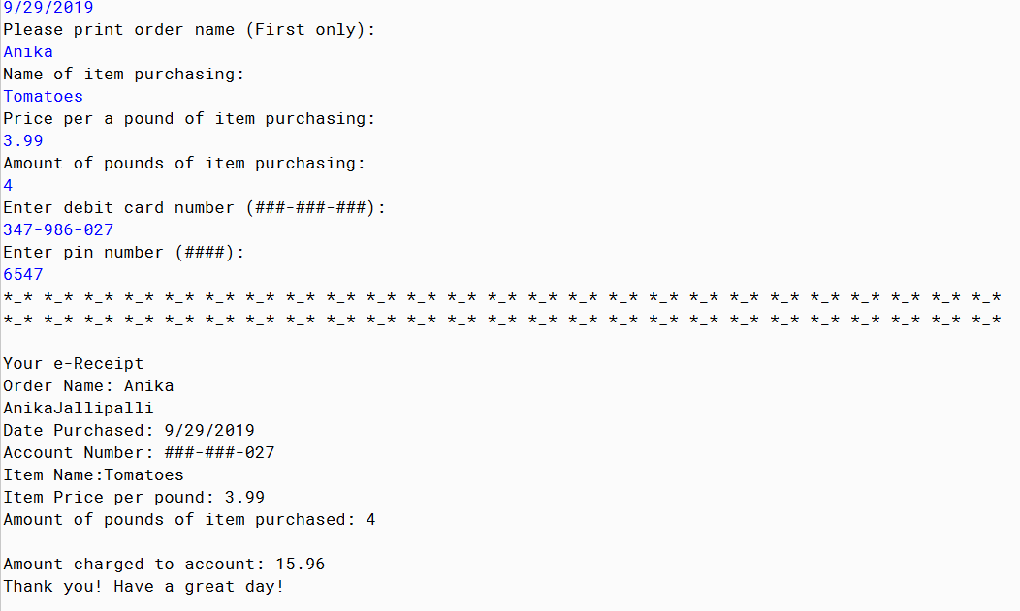

PMR: This assignment was good review of code. I was actually quite proud of myself for being able to remember how to do everything. I am happy with the code I produced.

/**

* Write a description of class BuyingVegetables here.

* Shopper should be able to list type of vegetable and price per a pound and get a digital reciept

*

* @author Anika Jallipalli

* @version 9/28/2019

*/

import java.util.Scanner;

public class BuyingVegetables

{

public static void main(String [] args)

{

Scanner in = new Scanner(System.in);

System.out.println("");

System.out.println("Hello! Thank you for shopping at SmartShopper!");

System.out.println("");

System.out.println("Please print first and last name:");

String word1= in.next();

String word2= in.next();

System.out.println("Please print date (mm/dd/yyyy): ");

String word4= in.next();

System.out.println("Please print order name (First only): ");

String word10 = in.next();

System.out.println("Name of item purchasing: " );

String word3= in.next();

System.out.println("Price per a pound of item purchasing: ");

double doubleValue1 = in.nextDouble();

System.out.println("Amount of pounds of item purchasing: ");

int intValue1 = in.nextInt();

System.out.println("Enter debit card number (###-###-###): ");

String word5= in.next();

System.out.println("Enter pin number (####): ");

String word6= in.next();

System.out.println("*_* *_* *_* *_* *_* *_* *_* *_* *_* *_* *_* *_* *_* *_* *_* *_* *_* *_* *_* *_* *_* *_* *_* *_* *_*");

System.out.println("*_* *_* *_* *_* *_* *_* *_* *_* *_* *_* *_* *_* *_* *_* *_* *_* *_* *_* *_* *_* *_* *_* *_* *_* *_*");

System.out.println("");

System.out.println("Your e-Receipt");

System.out.println("Order Name: " + word10);

System.out.print( word1 );

System.out.println(word2);

System.out.println("Date Purchased: " + word4);

System.out.println("Account Number: ###-###-" +word5.substring(8,11));

System.out.println("Item Name:" + word3);

System.out.println("Item Price per pound: " + doubleValue1);

System.out.println("Amount of pounds of item purchased: " + intValue1);

System.out.println("");

System.out.println("Amount charged to account: "+ (doubleValue1*intValue1));

System.out.println("Thank you! Have a great day!");

}

}